User Guide
How to place an order.

For orders, visit www.parmalat.qtco.com.au. Log on by clicking the Login tab on the top right of the home page screen. Then use the username and password you have been provided.

- On the catalogue page, select either clothing or roles.
The Roles tab is best if you need to order an entitlement or see what entitlements a role has.
Clothing is best if you need to order a specific item of clothing.

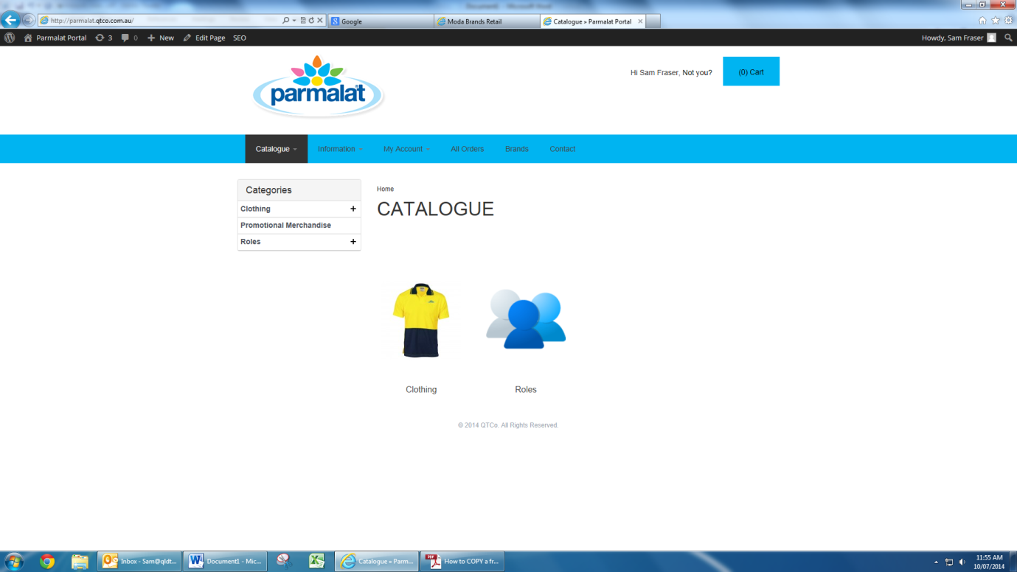

1a. The clothing tab will take you into the sub categories of the clothing products, for example, pants or shirts.

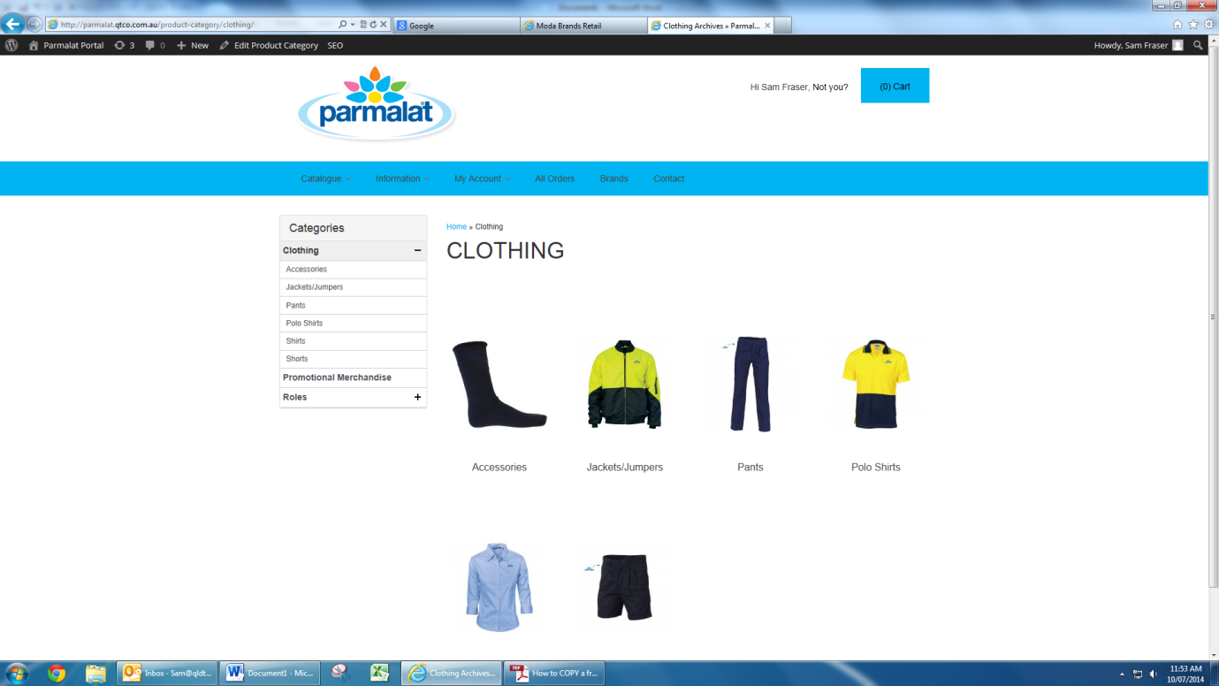

1b. If you choose the roles category this will show the role departments to further search for a specific role and the role entitlements. For example if you are ordering for a transport driver you can search under transport/distribution roles for the role and entitlements.

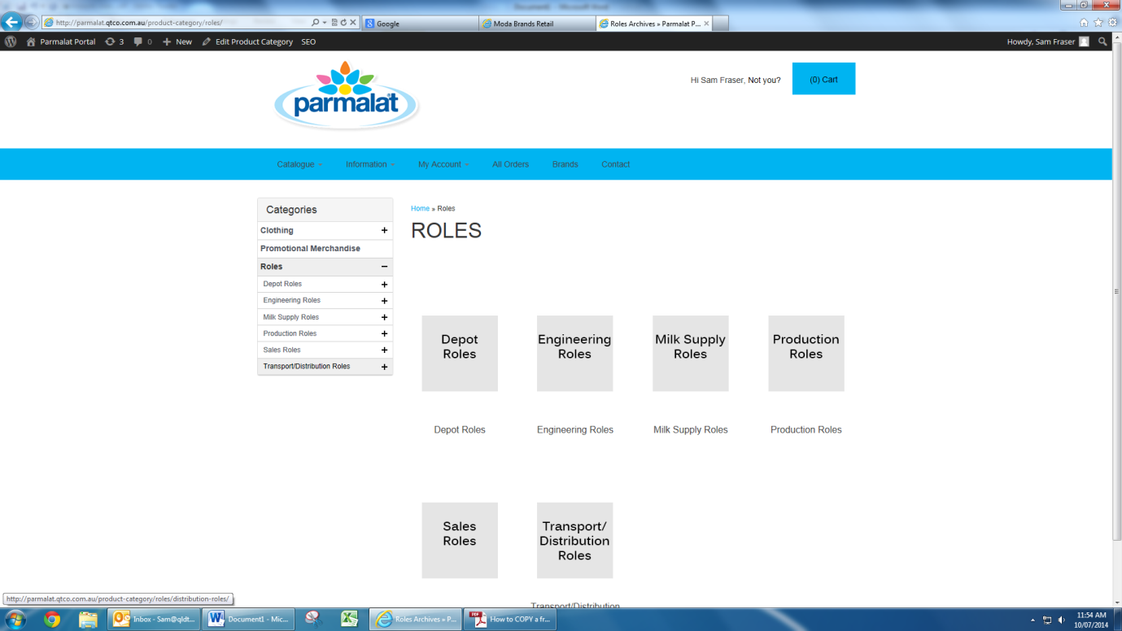

- If you already know what item you need to purchase, select clothing and then a product type for example, polo shirts. This will then show a list of the approved polo shirt styles. Click on the style you require.

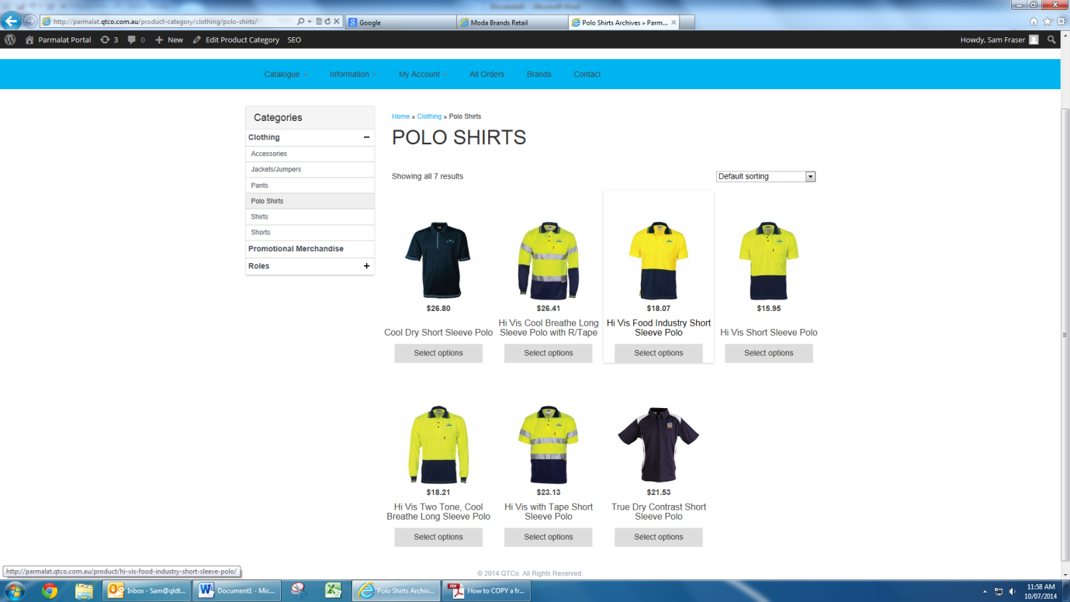

- This will bring to the individual product page. By scrolling down the page you will see a list of the sizes and measurements this style is available in, as well as a product description and the fabric content. If ordering you need to select the colour, size and quantity you would like to order. Once these selections are made, click ‘add to cart’.

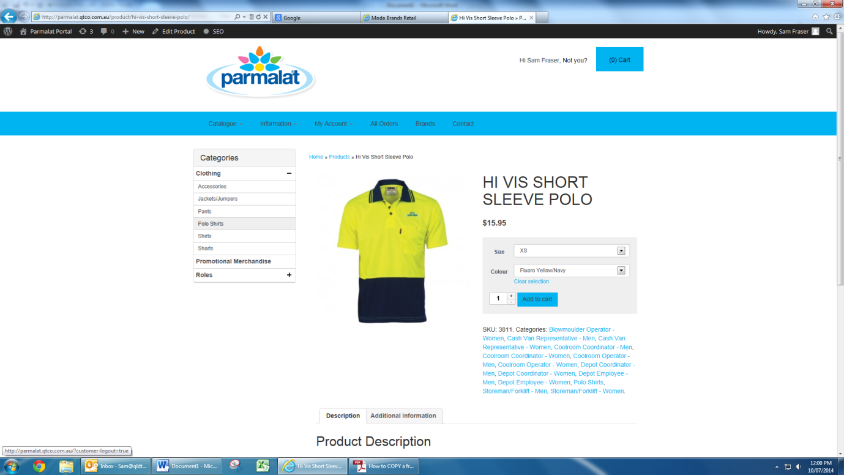

- Once items are added, you will see the following message appear on the product page.

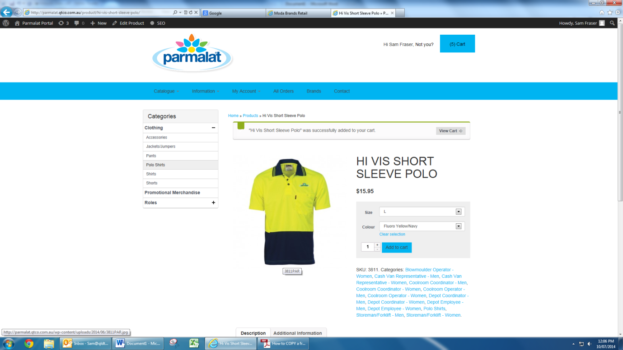

- If more products are needed for the order, simply click on the clothing category you need and again select the product you are after and continue to add items to your cart.

- Once all items are added in to the cart, click on the blue cart tab.

- This brings you to the cart page. If you would like to amend the quantity ordered, click on the + or – signs.

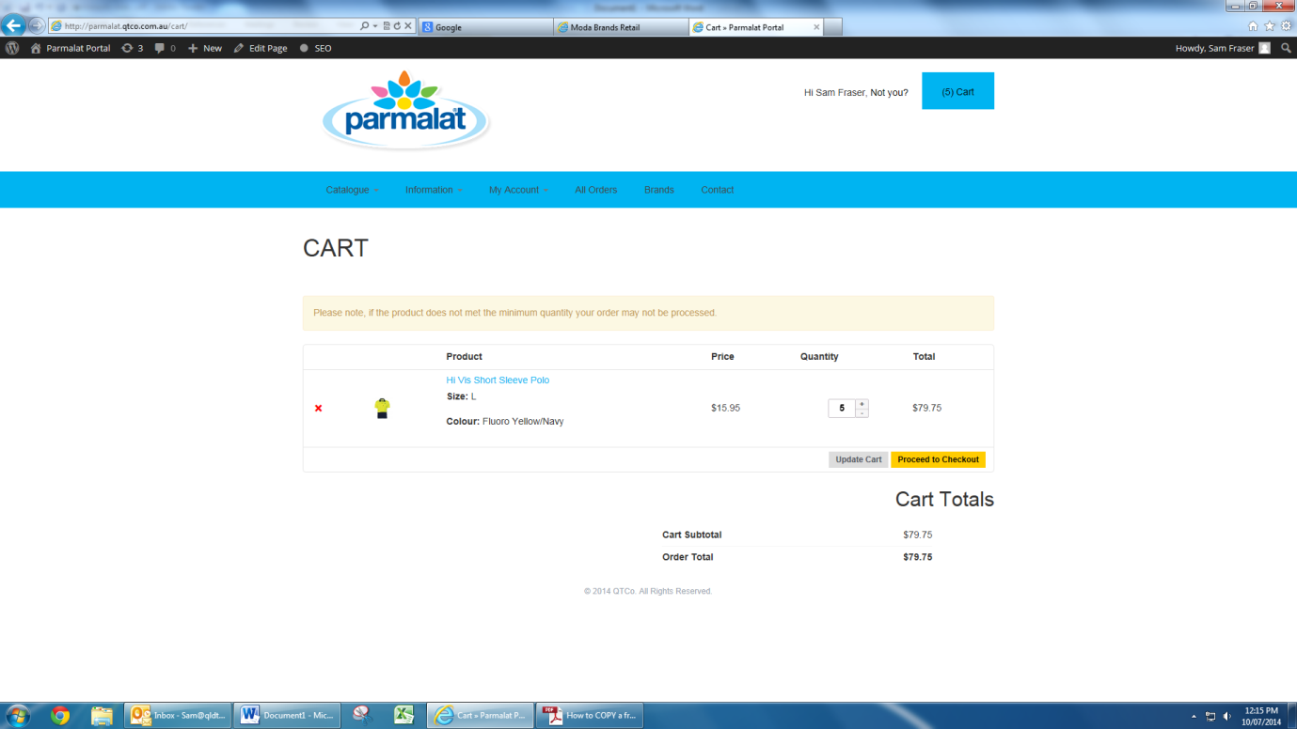

- If you would like to delete the style, click on the ‘red cross’ symbol.

- Once happy with items in the cart, click on ‘proceed to checkout’.

- In the checkout screen you need to complete the billing details section. Add your name and the name of the person you are ordering for.

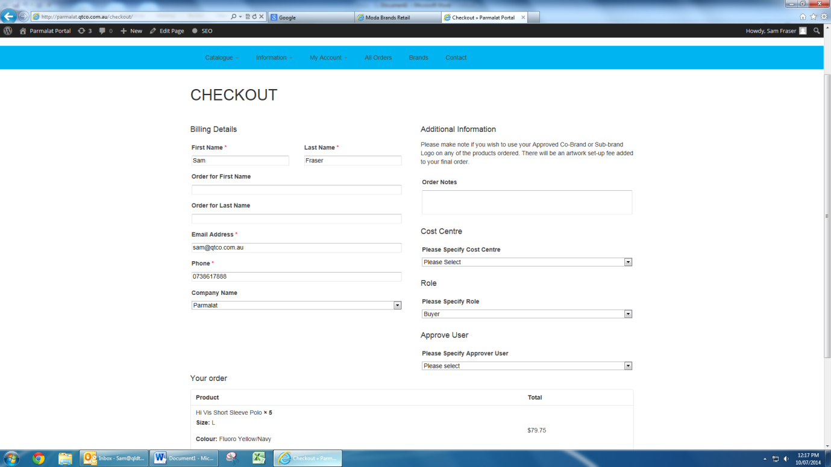

- Add your email address and phone number. Then choose from the drop down selection of the company you are ordering for.

- If there are any specific notes you would like to inform QTCo about, please add these into ‘order notes’.

- Now choose the cost centre you are ordering for from the drop down list. If you are only associated with one cost centre, the selection will not need to be made.

- Select the role for which the ordered stock is being placed for.

- If you have more than one approver for your orders, please select which approver needs to be advised for this order – approver will correspond to the cost centre selected.

- Finally click on ‘place order’ when completed.

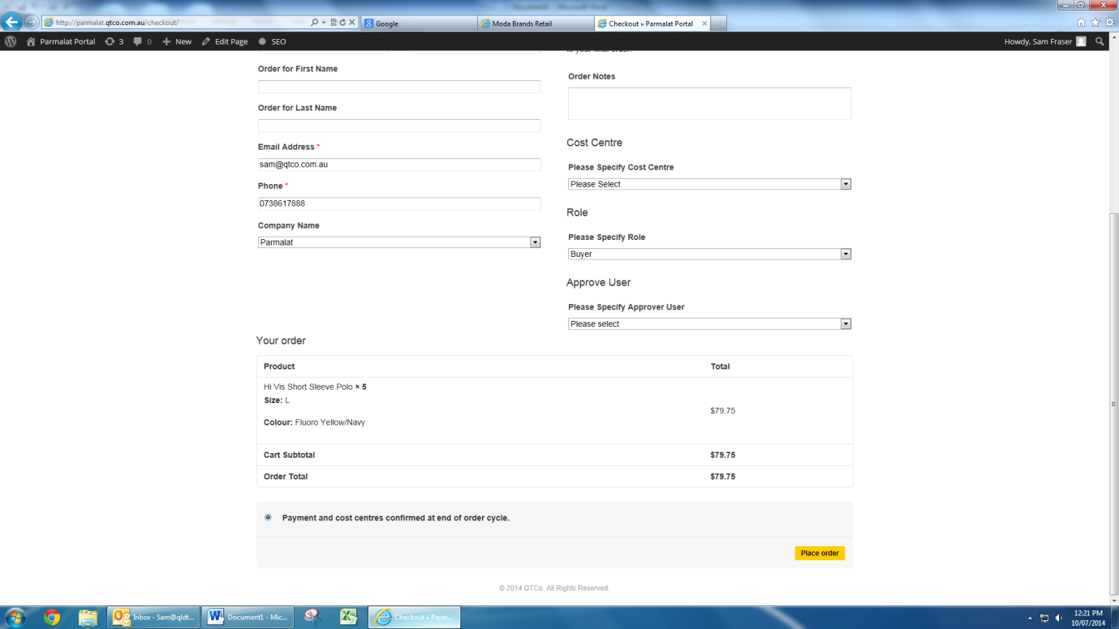

- The final checkout screen appears stating that your order has been received and listing the order number.

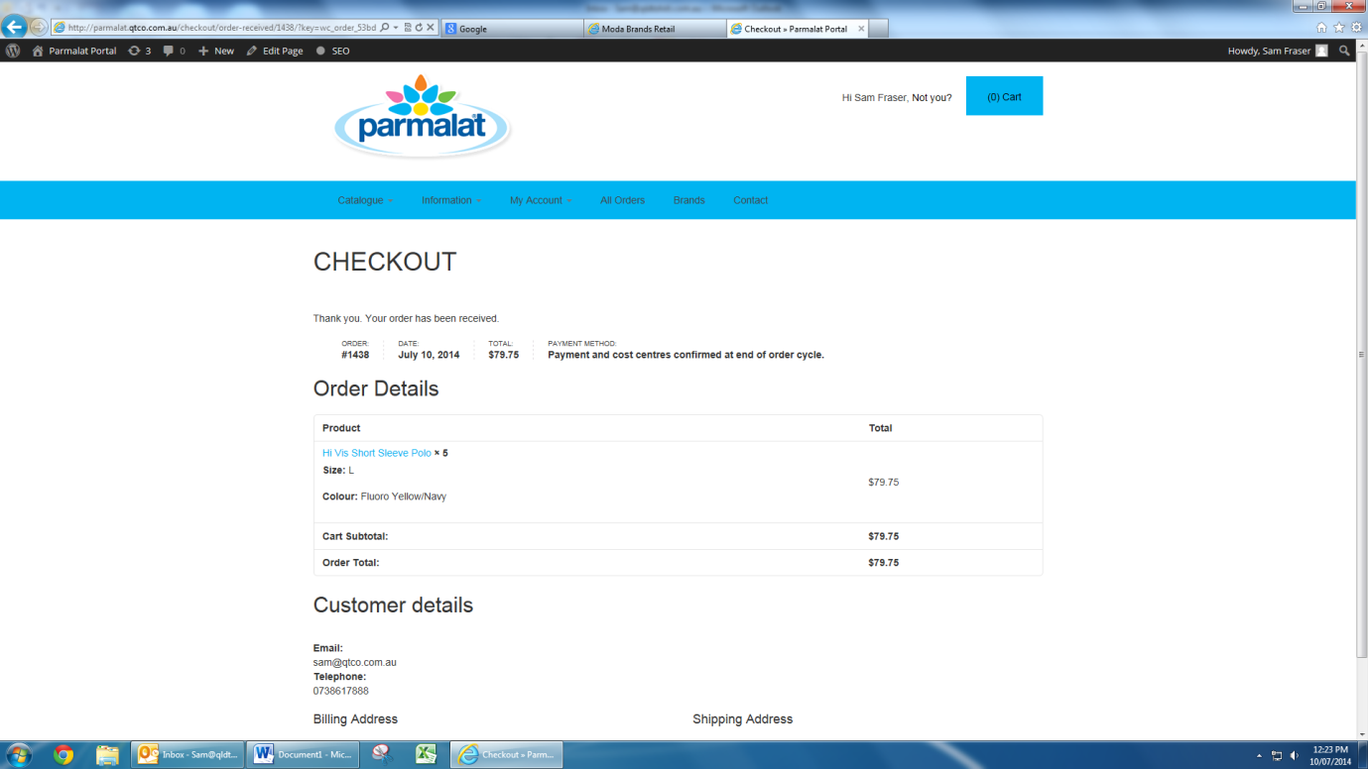

- Once order has been placed an email notification will be sent to your email address and also to the email address of your approver.

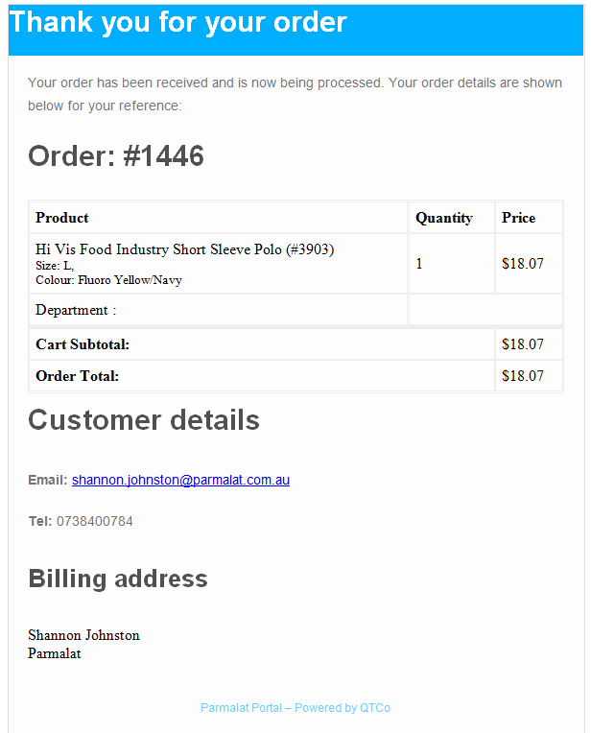

- When the approver receives the email notification they must finalise the order by clicking on the yes or no tab in the email.

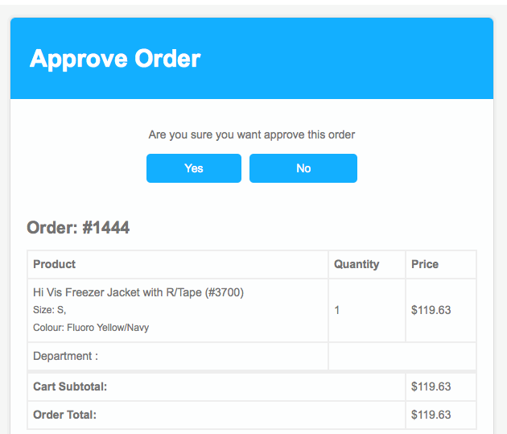

- Once the order is approved you will receive another email notification advising that your order has been approved for processing. This means that your order has been put into production by QTCo.

- Once your order is ready and despatched you will receive another email advising that your order has now been completed and sent. Therefore your goods should arrive to you within the specified timeframe listed in the delivery tab of the portal.

- If you do not receive email confirmation for your order, the information is incorrect or you need to change your order after sending, please contact QTCO on:

Contact Name – Petrina Malyon, petrina@qtco.com.au or phone 07 3861 7888.

- Note there is information for your reference on the web portal (blue bar) on the below:
- Lead times,
- FAQ,
- Contracted items including garment codes and brands,
- Parmalat Uniform Policy.

